NATIONAL UNIVERSITY OF SCIENCES AND TECHNLOGY

(DEPARTMENT OF MECHANICAL ENGINEERING)

FUNDAMENTALS OF PROGRAMMING

NAME: Syed Ali Naqi

SUBMITTED ON: 17-10-2023

CMS ID: 466889

Task 1

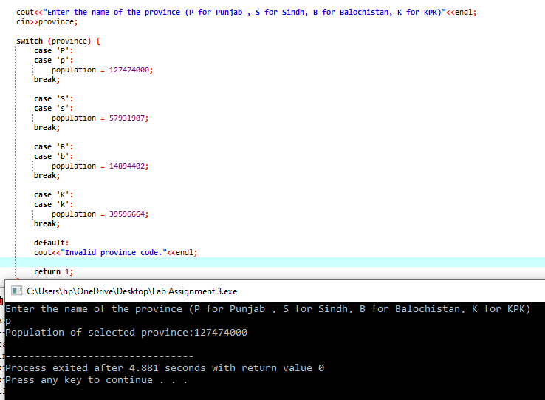

Task 2

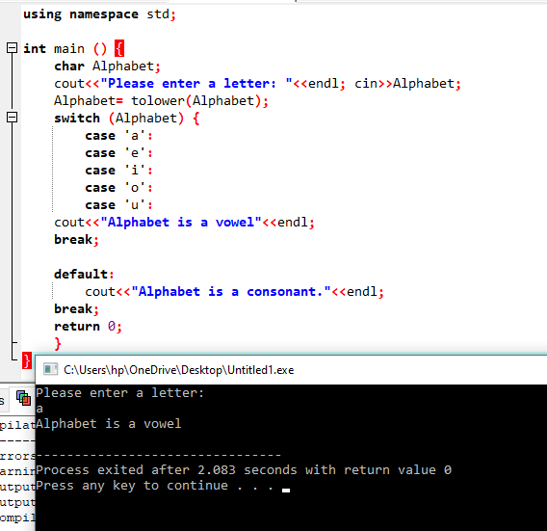

Task 3

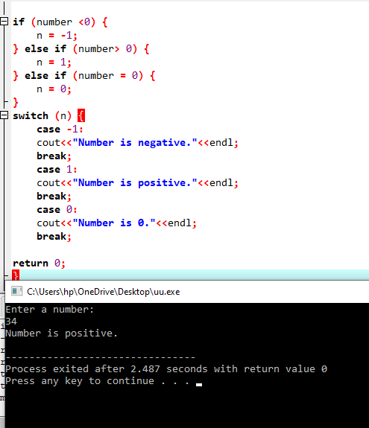

Task 4

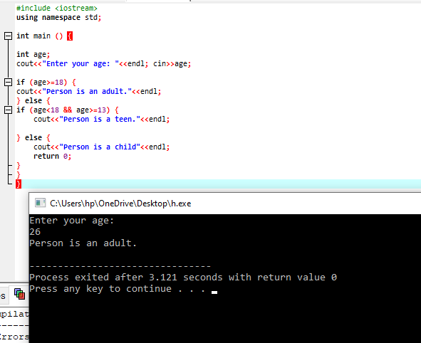

Task 5

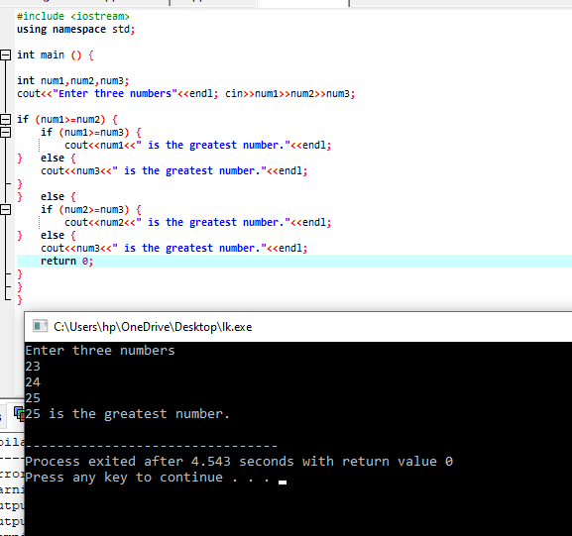

Task 6

